Curved Surface

Definition
# Source: AI Source: Provided by: [Data Path: Persons Table -> ID Column: 1, Name_En Column: Motasem Essam] -> From: [ChatGPT] on [7/20/2026]
A curved surface is a two-dimensional geometric surface that is not flat and bends in at least one direction.
Unlike a plane surface, a curved surface does not have zero curvature everywhere. It may bend in one direction, such as the lateral surface of a cylinder, or in two directions, such as the surface of a sphere.
Examples include:
- The surface of a sphere
- The curved lateral surface of a cylinder
- The curved surface of a cone
- The surface of a torus
A curved surface has two dimensions but, like an ideal plane surface, has no thickness.
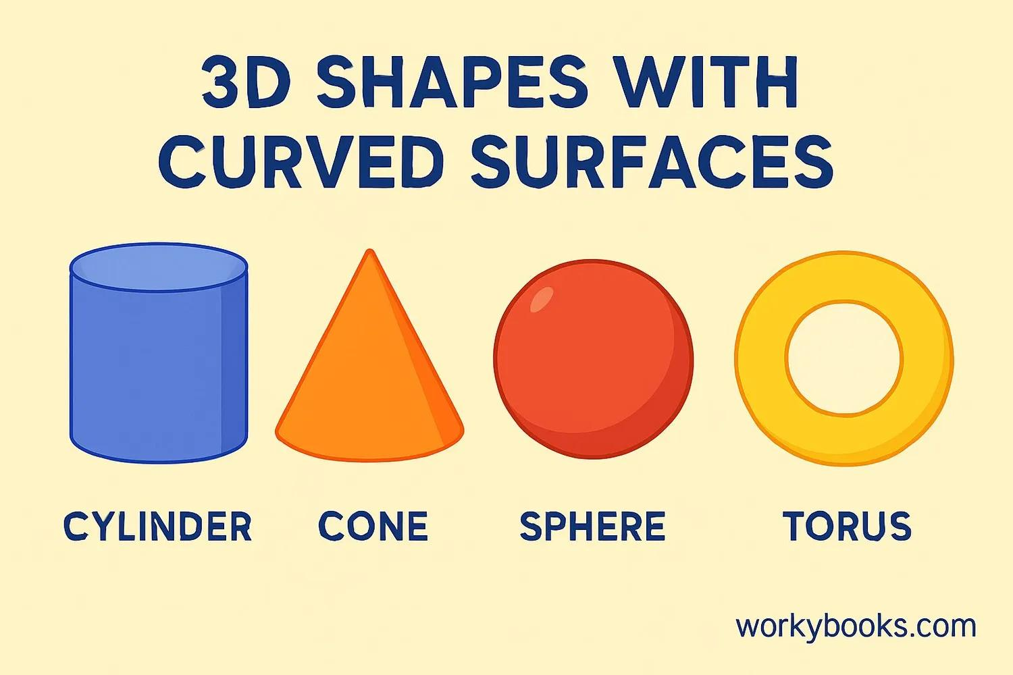
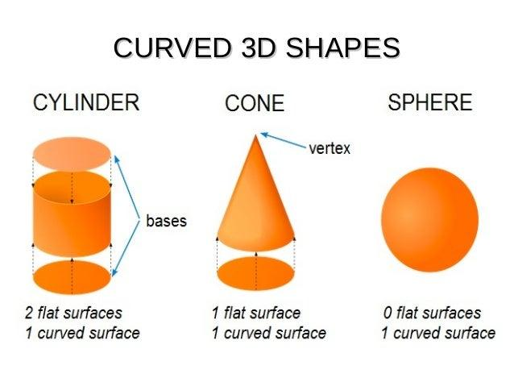
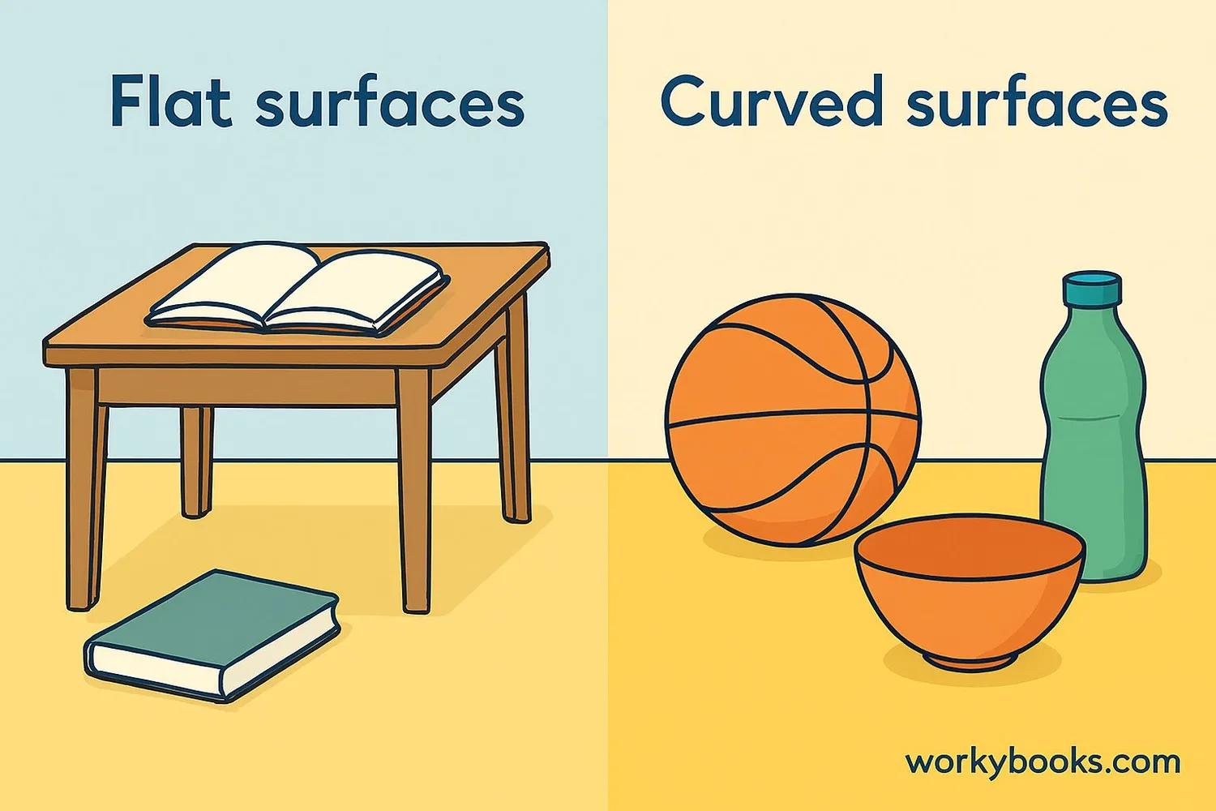
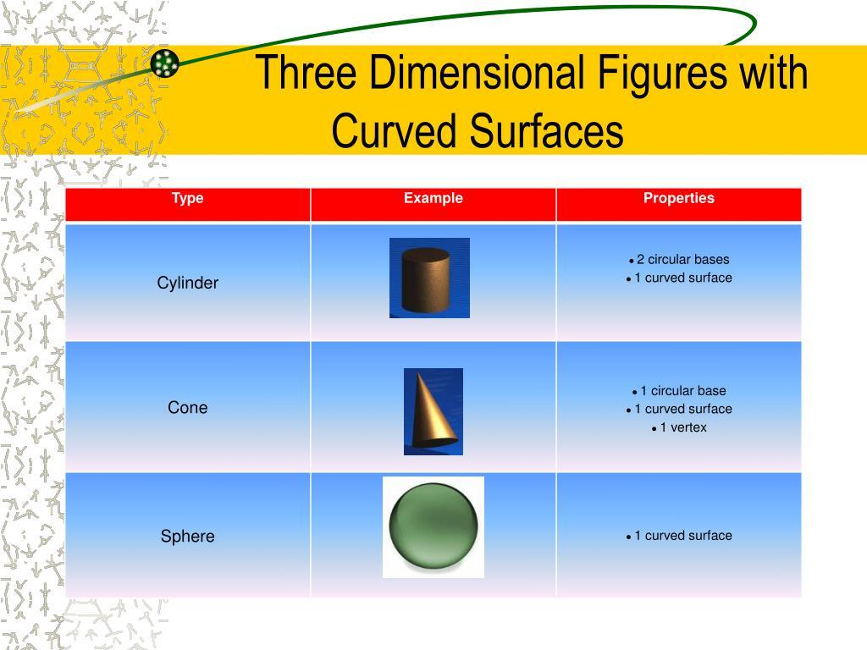
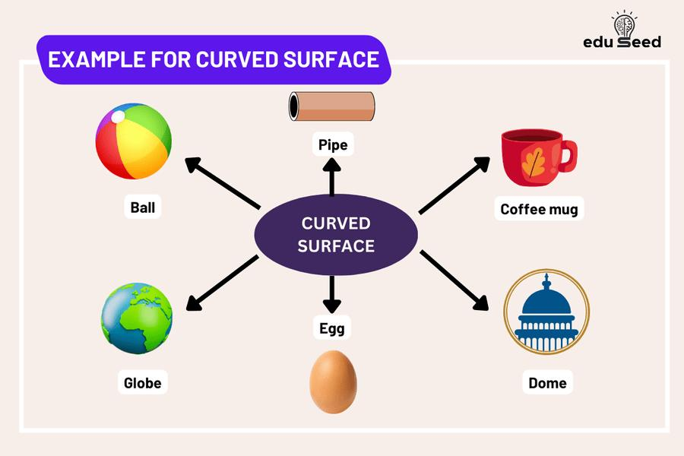

Purpose
# Source: AI Source: Provided by: [Data Path: Persons Table -> ID Column: 1, Name_En Column: Motasem Essam] -> From: [ChatGPT] on [7/20/2026]
Curved surfaces are used to:
- Describe the boundaries of curved three-dimensional objects.
- Study the geometry of spheres, cylinders, cones, and other curved objects.
- Calculate curved surface area and total surface area.
- Model curved objects in engineering and architecture.
- Study curvature and the geometry of surfaces.
- Represent real-world curved structures mathematically.

Fundamental Characteristics

1. Two-Dimensional
# Source: AI Source: Provided by: [Data Path: Persons Table -> ID Column: 1, Name_En Column: Motasem Essam] -> From: [ChatGPT] on [7/20/2026]
A curved surface is a two-dimensional geometric object.
It has two independent directions along the surface, but it does not have volume.
$$\boxed{\text{Dimension of a surface}=2}$$

2. No Thickness
# Source: AI Source: Provided by: [Data Path: Persons Table -> ID Column: 1, Name_En Column: Motasem Essam] -> From: [ChatGPT] on [7/20/2026]
An ideal geometric surface has no thickness:
$$\boxed{\text{Thickness}=0}$$
A physical curved object has material thickness, but the mathematical surface represents only its outer boundary.

3. Curvature
# Source: AI Source: Provided by: [Data Path: Persons Table -> ID Column: 1, Name_En Column: Motasem Essam] -> From: [ChatGPT] on [7/20/2026]
The defining characteristic is that the surface bends.
Unlike a plane:
$$\text{Plane curvature}=0$$
a curved surface generally has nonzero curvature in at least some locations.

4. Can Be Part of a Solid
# Source: AI Source: Provided by: [Data Path: Persons Table -> ID Column: 1, Name_En Column: Motasem Essam] -> From: [ChatGPT] on [7/20/2026]
A curved surface can form part or all of the boundary of a three-dimensional solid.
For example:
- Sphere → entirely curved surface
- Cylinder → curved lateral surface + two plane surfaces
- Cone → curved lateral surface + one plane surface

Main Types of Curved Surfaces

1. Spherical Surface
# Source: AI Source: Provided by: [Data Path: Persons Table -> ID Column: 1, Name_En Column: Motasem Essam] -> From: [ChatGPT] on [7/20/2026]
A spherical surface is the set of all points at a fixed distance $r$from a fixed center $O$.
$$OP=r$$
for every point $P$on the surface.
Its surface area is:
$$SA=4πr^{2}$$
Example: the mathematical surface of a ball.
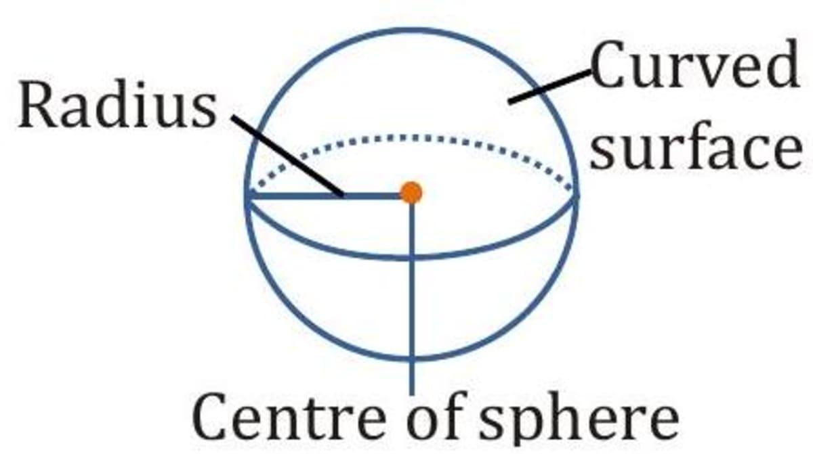
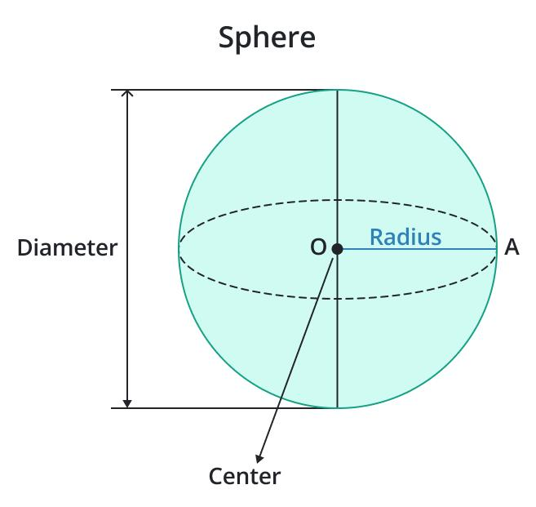
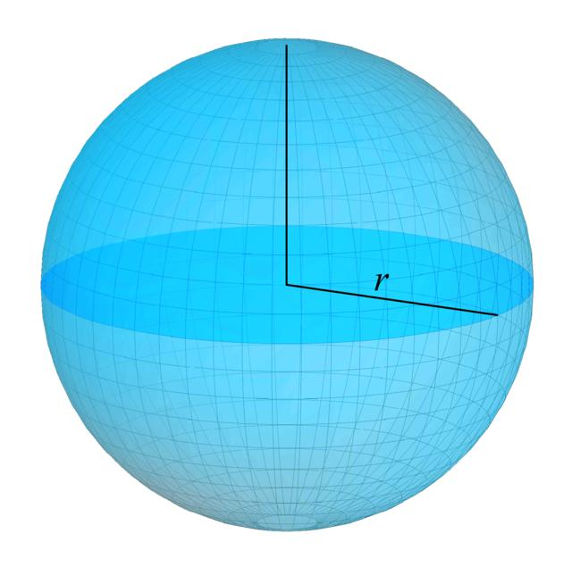
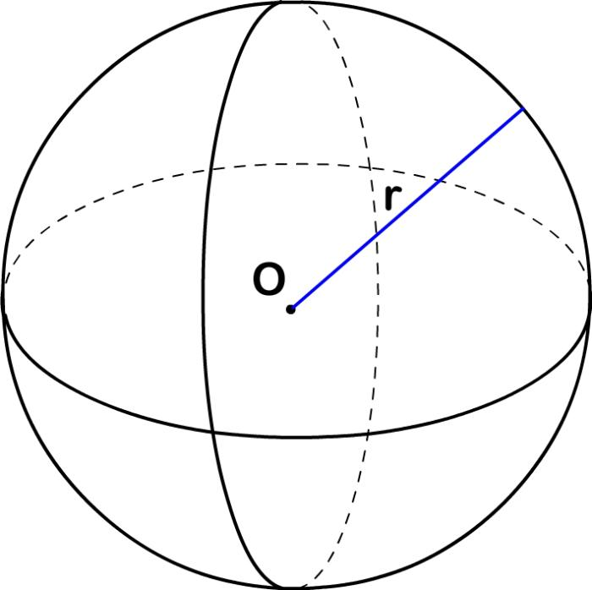
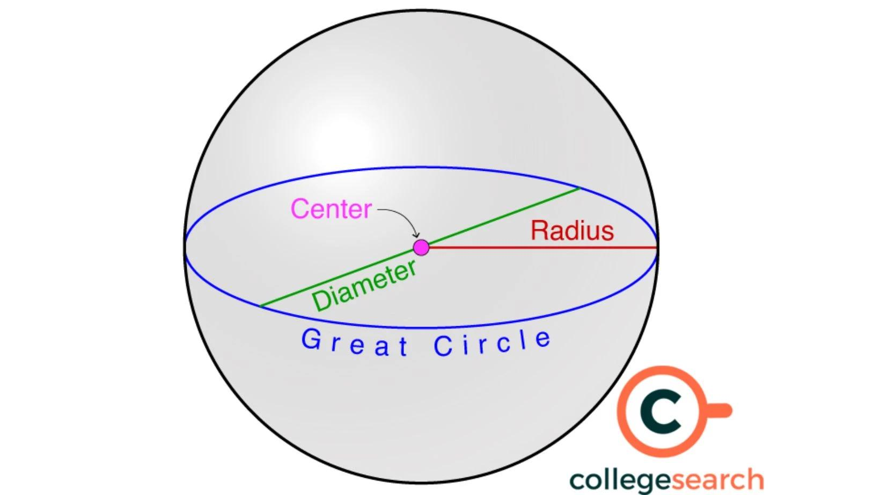

2. Cylindrical Surface
# Source: AI Source: Provided by: [Data Path: Persons Table -> ID Column: 1, Name_En Column: Motasem Essam] -> From: [ChatGPT] on [7/20/2026]
A cylindrical surface is the curved lateral surface generated by a line moving parallel to a fixed line while remaining at a constant distance from it.
For a right circular cylinder with radius $r$and height $h$, the curved lateral surface area is:
$$A_{\text{lateral}}=2πrh$$
The complete cylinder also has two plane circular surfaces:
$$A_{\text{bases}}=2πr^{2}$$
Therefore:
$$SA=2πrh+2πr^{2}$$
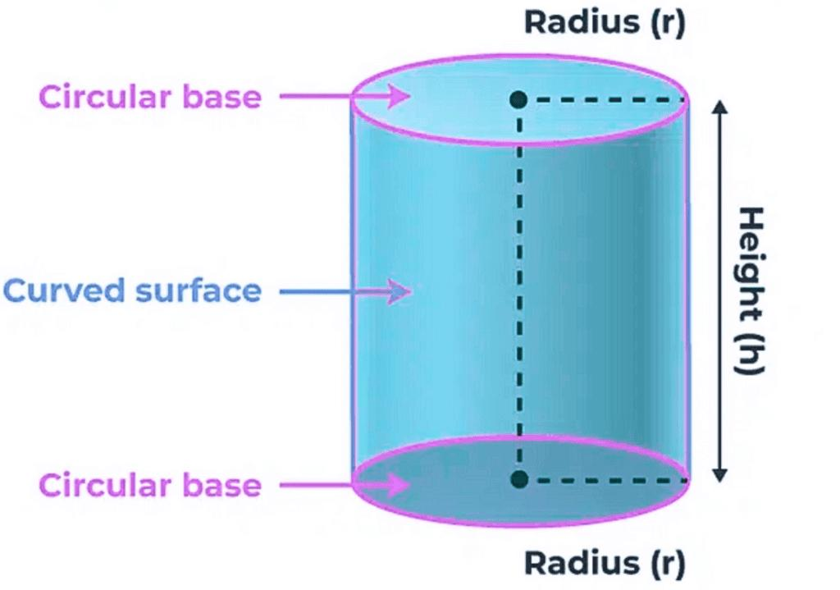
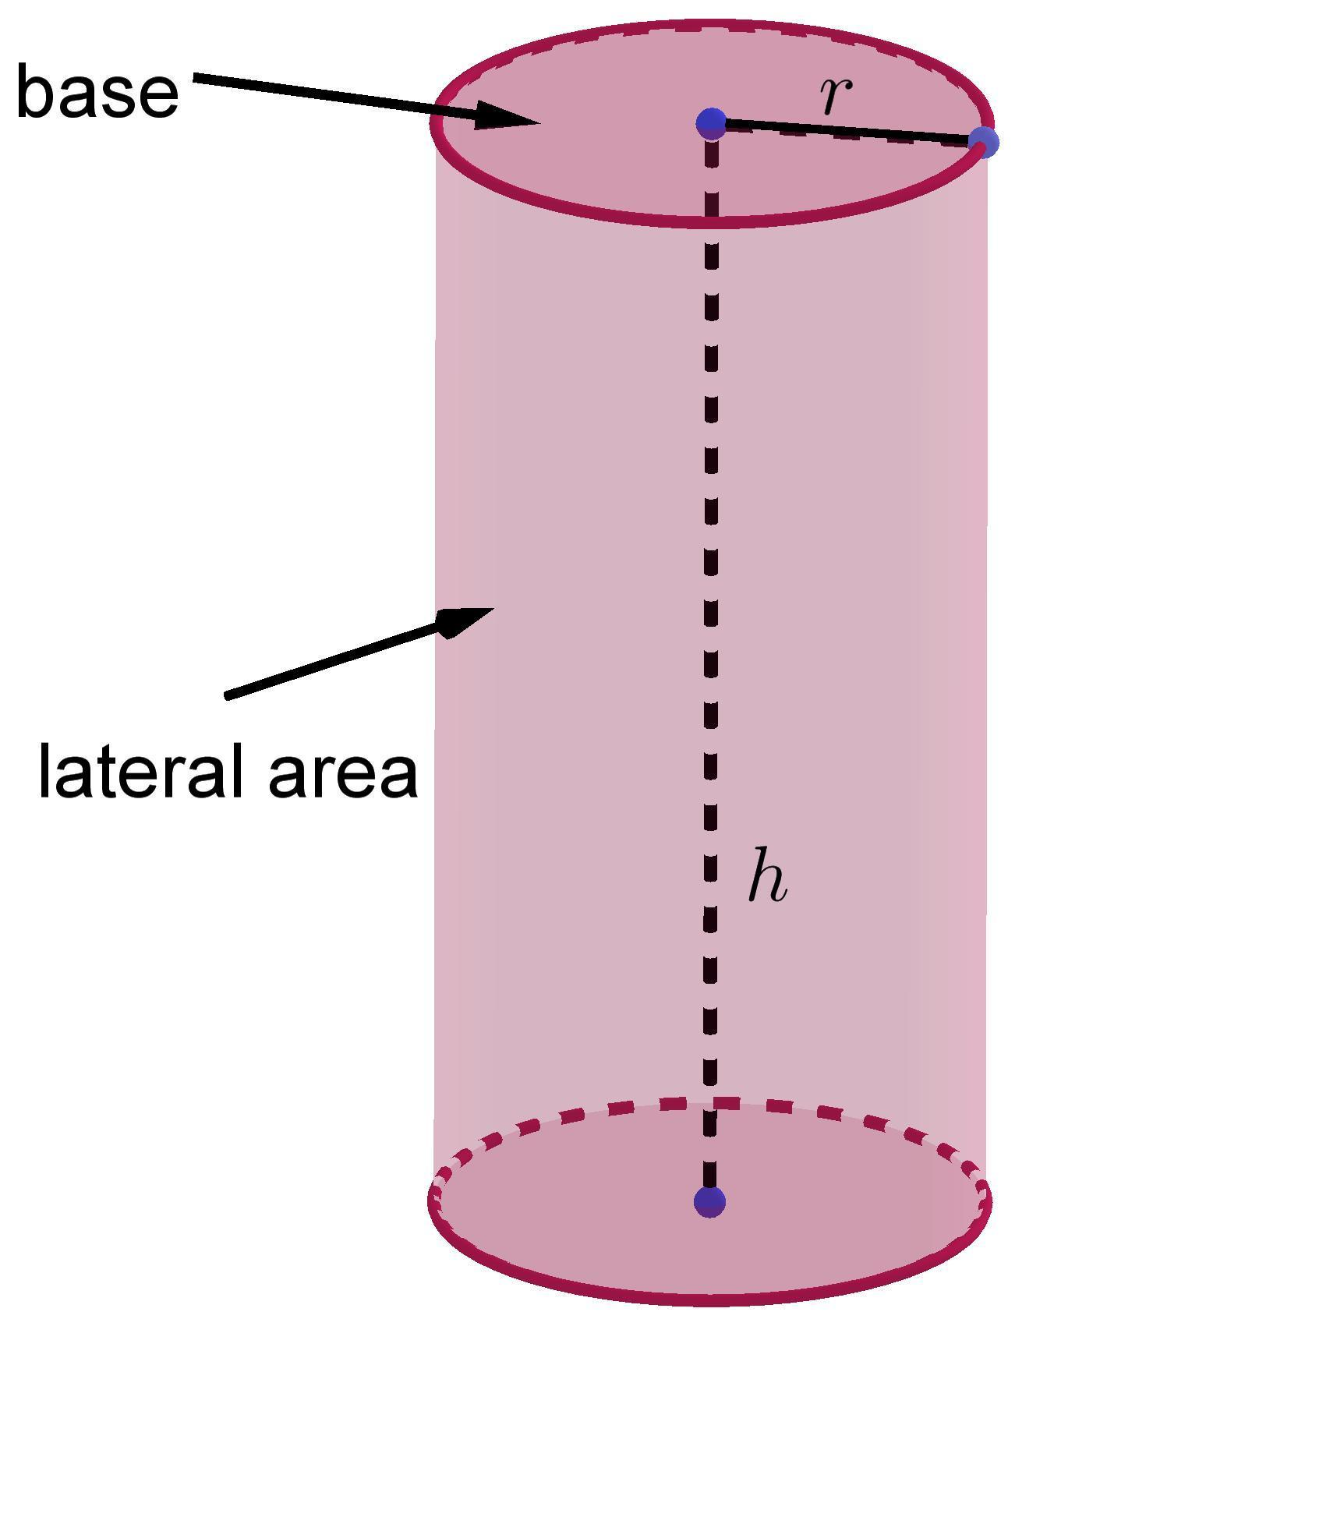
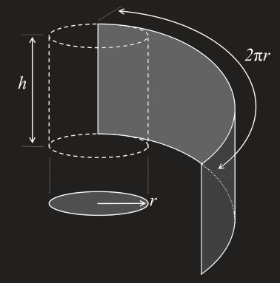
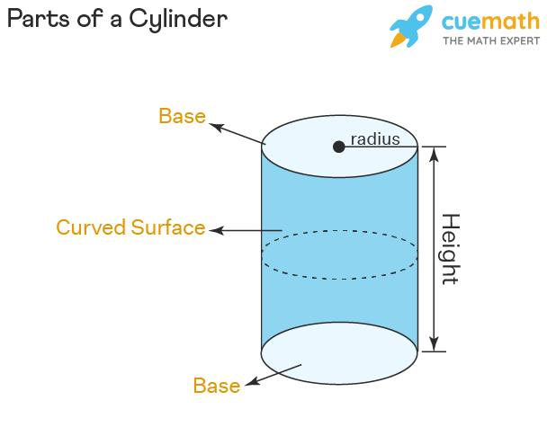
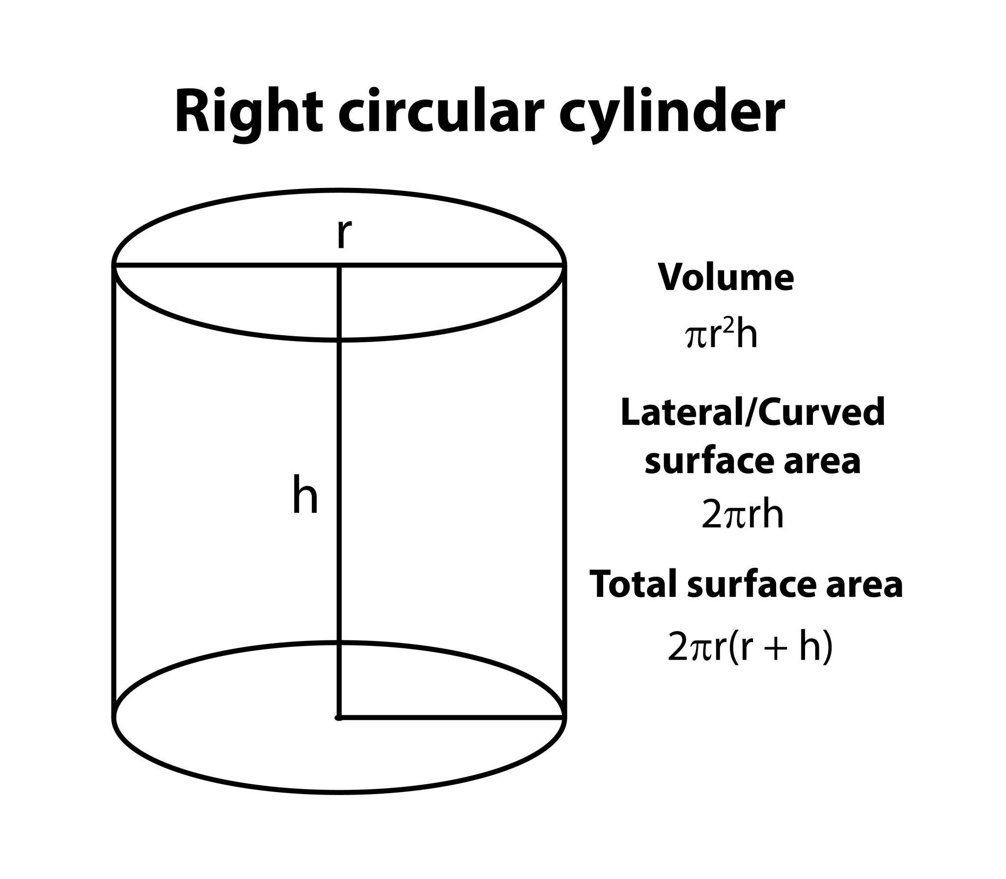

3. Conical Surface
# Source: AI Source: Provided by: [Data Path: Persons Table -> ID Column: 1, Name_En Column: Motasem Essam] -> From: [ChatGPT] on [7/20/2026]
A conical surface is the curved lateral surface of a cone.
For a right circular cone with radius $r$and slant height $l$:
$$A_{\text{lateral}}=πrl$$
If the circular base is included:
$$SA=πrl+πr^{2}$$
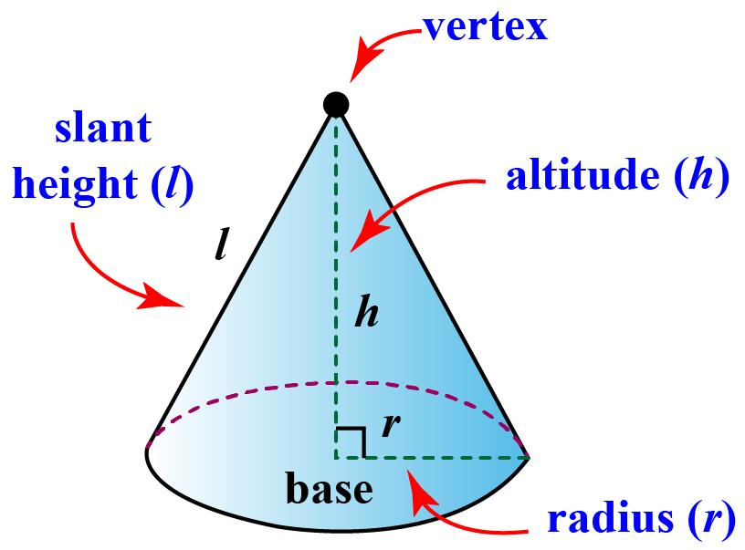
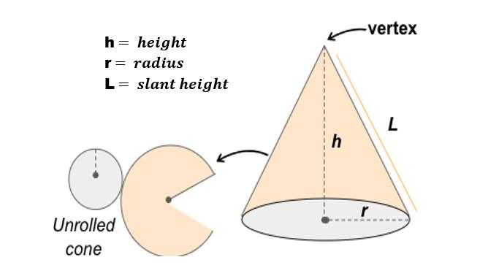
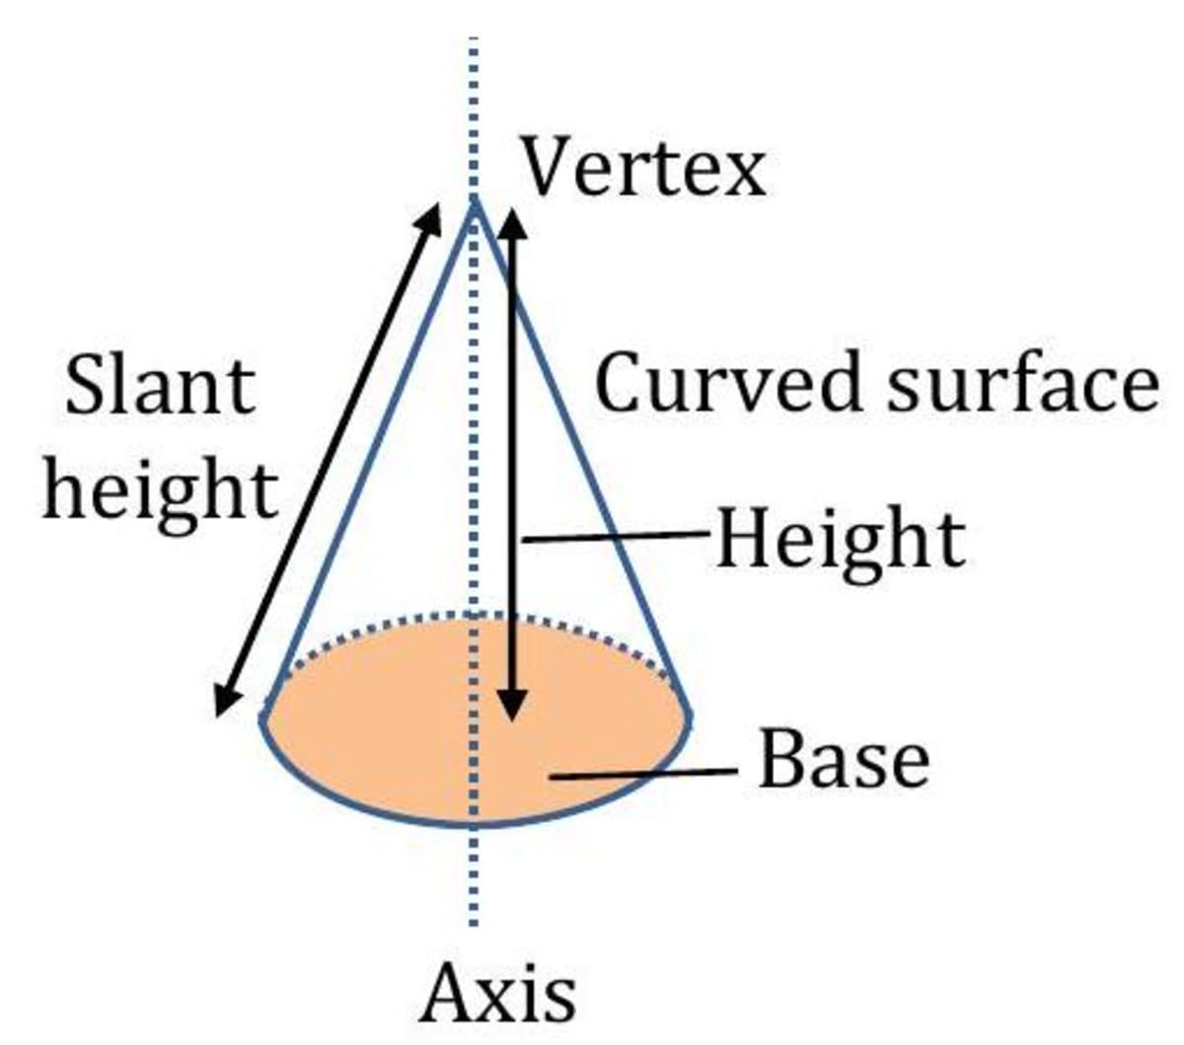
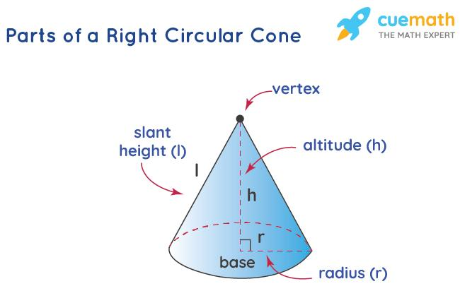

4. Toroidal Surface
# Source: AI Source: Provided by: [Data Path: Persons Table -> ID Column: 1, Name_En Column: Motasem Essam] -> From: [ChatGPT] on [7/20/2026]
A toroidal surface is the curved surface of a torus, commonly resembling a doughnut.
It is generated by rotating a circle around an external axis in the same plane as the circle.
For a torus with major radius $R$and minor radius $r$:
$$SA=4π^{2}Rr$$
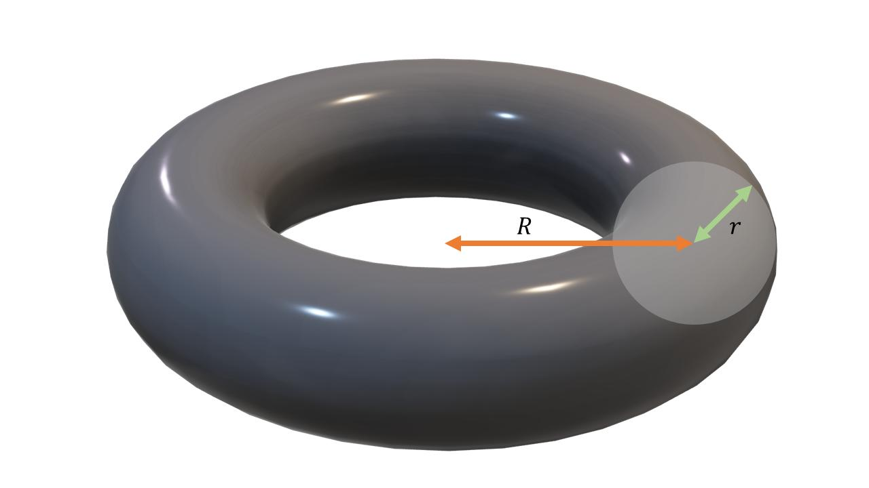
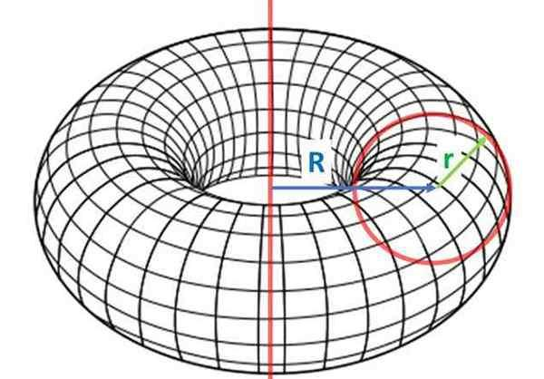
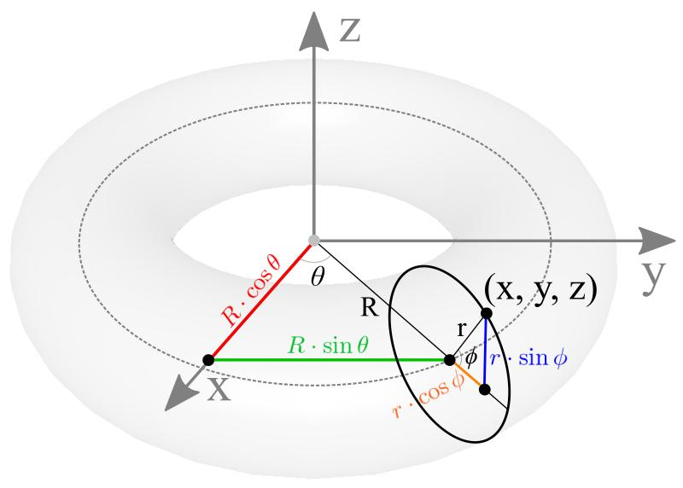
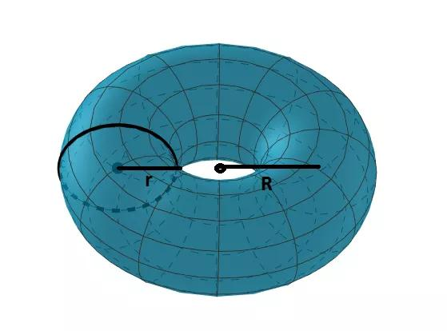
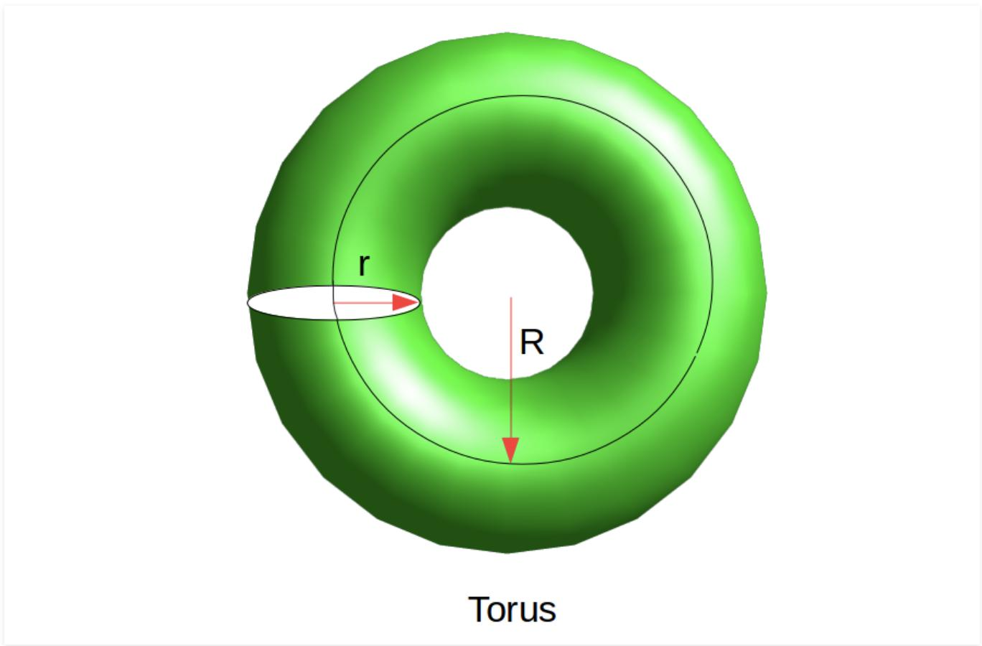

Curved Surface Area
# Source: AI Source: Provided by: [Data Path: Persons Table -> ID Column: 1, Name_En Column: Motasem Essam] -> From: [ChatGPT] on [7/20/2026]
Curved surface area is the area of a curved portion of a three-dimensional object's boundary.
It is often distinguished from total surface area.
Cylinder
Curved surface area:
$$CSA=2πrh$$
Total surface area:
$$TSA=2πrh+2πr^{2}$$
Cone
Curved surface area:
$$CSA=πrl$$
Total surface area:
$$TSA=πrl+πr^{2}$$
For a sphere, the entire boundary is curved:
$$SA=4πr^{2}$$

Example
# Source: AI Source: Provided by: [Data Path: Persons Table -> ID Column: 1, Name_En Column: Motasem Essam] -> From: [ChatGPT] on [7/20/2026]
Consider a cylinder with:
$$r=3\text{ cm}$$
and
$$h=10\text{ cm}$$
The curved surface area is:
$$CSA=2πrh \\ CSA=2π\left(3\right)\left(10\right) \\ \boxed{CSA=60π{\text{ cm}}^{2}}$$
Approximately:
$$CSA≈188.50{\text{ cm}}^{2}$$

Curved Surface vs Plane Surface
# Source: AI Source: Provided by: [Data Path: Persons Table -> ID Column: 1, Name_En Column: Motasem Essam] -> From: [ChatGPT] on [7/20/2026]
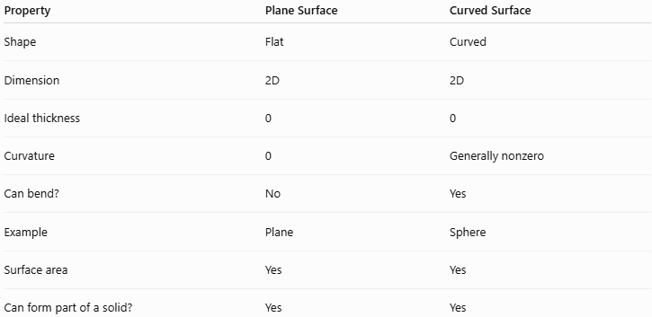
Property | Plane Surface | Curved Surface
Shape | Flat | Curved
Dimension | 2D | 2D
Ideal thickness | 0 | 0
Curvature | 0 | Generally nonzero
Can bend? | No | Yes
Example | Plane | Sphere
Surface area | Yes | Yes
Can form part of a solid? | Yes | Yes
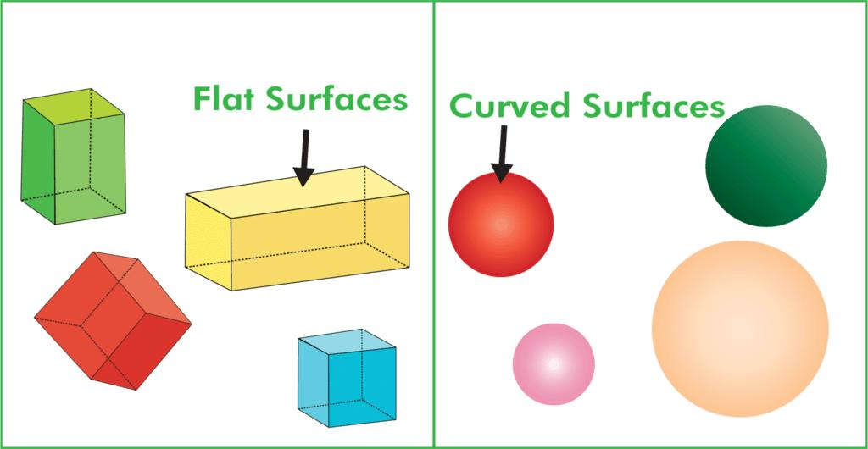
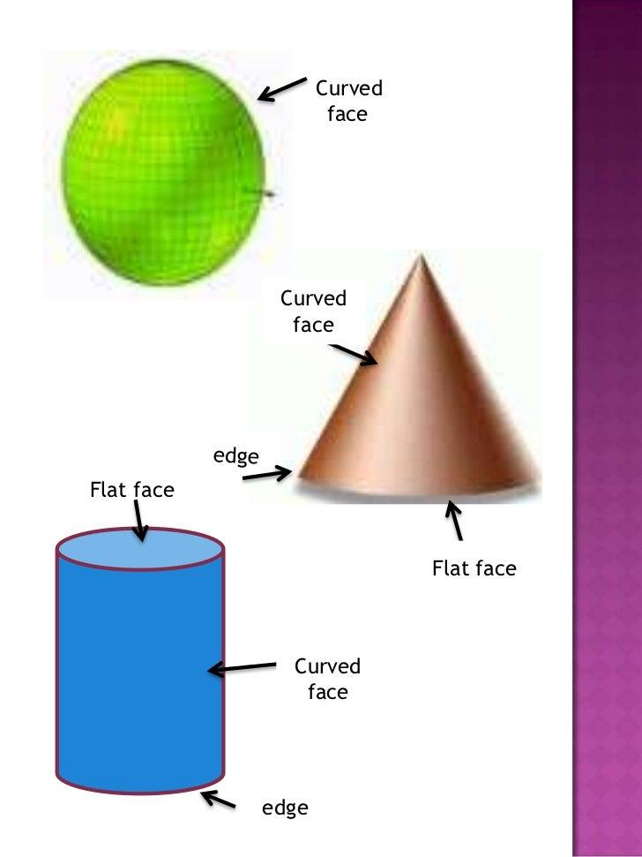
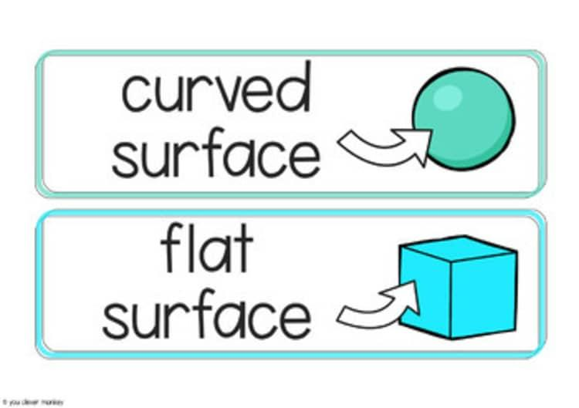

Curved Surface vs Solid
# Source: AI Source: Provided by: [Data Path: Persons Table -> ID Column: 1, Name_En Column: Motasem Essam] -> From: [ChatGPT] on [7/20/2026]
A curved surface is not the same as the solid it bounds.
For example:
Sphere
The spherical surface is:
$$\boxed{SA=4πr^{2}}$$
The solid sphere has volume:
$$\boxed{V=\frac{4}{3}πr^{3}}$$
Therefore:
$$\text{Surface}→\text{Area}$$
while:
$$\text{Solid}→\text{Volume}$$

Curved Surface vs Plane
# Source: AI Source: Provided by: [Data Path: Persons Table -> ID Column: 1, Name_En Column: Motasem Essam] -> From: [ChatGPT] on [7/20/2026]
These concepts should also be kept distinct:
- Plane → a fundamental flat geometric object.
- Plane Surface → a flat type of surface.
- Curved Surface → a non-flat type of surface.
Thus:
$$\boxed{\text{Surface}=\text{Plane Surface or Curved Surface}}$$
as a basic classification.

Real-World Applications
# Source: AI Source: Provided by: [Data Path: Persons Table -> ID Column: 1, Name_En Column: Motasem Essam] -> From: [ChatGPT] on [7/20/2026]
Curved surfaces appear extensively in:
- Architecture
- Mechanical engineering
- Aerospace engineering
- Automotive design
- Industrial design
- Computer graphics
- CAD modeling
- Ship and aircraft design
- Optics
- Astronomy
- Manufacturing
Examples include:
- Pipes → cylindrical surfaces
- Domes → approximately spherical surfaces
- Funnels → conical surfaces
- Tires → toroidal surfaces
- Aircraft bodies → complex curved surfaces

Relationship with Related Concepts
# Source: AI Source: Provided by: [Data Path: Persons Table -> ID Column: 1, Name_En Column: Motasem Essam] -> From: [ChatGPT] on [7/20/2026]
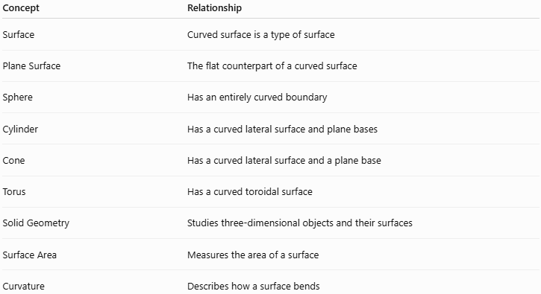
Concept | Relationship
Surface | Curved surface is a type of surface
Plane Surface | The flat counterpart of a curved surface
Sphere | Has an entirely curved boundary
Cylinder | Has a curved lateral surface and plane bases
Cone | Has a curved lateral surface and a plane base
Torus | Has a curved toroidal surface
Solid Geometry | Studies three-dimensional objects and their surfaces
Surface Area | Measures the area of a surface
Curvature | Describes how a surface bends

Key Points
# Source: AI Source: Provided by: [Data Path: Persons Table -> ID Column: 1, Name_En Column: Motasem Essam] -> From: [ChatGPT] on [7/20/2026]
- A curved surface is a two-dimensional surface that is not flat.
- It bends in at least one direction.
- An ideal curved surface has no thickness.
- Curved surfaces can form all or part of the boundary of a solid.
- Common examples include spherical, cylindrical, conical, and toroidal surfaces.
- Curved surface area measures the area of a curved portion of a boundary.
- A cylinder and cone have both curved and plane surfaces.
- A sphere has an entirely curved surface.
- Curved surfaces are especially important in Solid Geometry and surface-area calculations.

Conclusion
# Source: AI Source: Provided by: [Data Path: Persons Table -> ID Column: 1, Name_En Column: Motasem Essam] -> From: [ChatGPT] on [7/20/2026]
A curved surface is a non-flat, two-dimensional geometric surface that forms part or all of the boundary of many three-dimensional objects. Unlike a plane surface, it bends and generally has nonzero curvature. Spheres, cylinders, cones, and tori provide important examples, while curved surface area provides a practical way to measure such surfaces.
I can next organize Spherical Surface, Cylindrical Surface, Conical Surface, and Toroidal Surface as separate entries under this classification.

